08/11/17

RASCOFLEX Flexible Sprinkler Hose – 700 mm to 1800 mm Nominal Assembly Lengths

Flexible Sprinkler Hose with Fittings System

GENERAL DESCRIPTION
RASCOFLEX Flexible Sprinkler Hose with Fittings is an easy-to-install sprinkler drop assembly comprising branch line adapter nipple, no corrosive stainless steel flexible hose with nuts on each end, sprinkler reducer that connected to sprinkler head and ceiling bracket assembly that securely holds the sprinkler drop system to the ceiling grid.

The features and benefits of using RASCOFLEX Flexible Drop are easy installation, saving time and labor cost without any pipe threading, measuring and cutting, preventing any installation mistakes when following the proper installation instruction enclosed with flexible drops, and easier to test and charge the system with water before the ceiling grid is installed:

- Increase installation efficiency by reducing labour cost and installation time. The rate of installa- tion is two to three times faster than traditional fitting methods of installing sprinkler drops.

Increase efficiency in work flow by eliminating the traditional methods of installing sprinkler drops with no measuring and cutting. It is not necessary to use the traditional methods of installing sprinkler system, if an installer needs to adjust the level and alignment of sprinkler system and location. It is simply bended and maneuvered around ducts and trays in congested spaces.
- No need of heavy or special equipment to install the flexible sprinkler drops and save the cost asso- ciated with installation by eliminating pipe wastage; the waste comes from measuring, threading and cutting of pipes.
- Easy-To-Install since flexible sprinkler drops come with fully assembled system of flexible sprinkler drops that connect from branch line to sprinkler head.
- Corrosion-resistant materials by applying stainless steel 304 grade on flexible drops

RASCOFLEX Flexible sprinkler hoses described herein must be installed and maintained in compliance with this document and with the applicable standards recognized by the Approval agency such as LPCB, FM and UL guidelines as well as industry standards for the installation such as NFPA13, NFPA13D, NFPA13R, and other standards, in addition to the standards of any other authorities having jurisdiction. Failure to do so may hinder the performance of these devices.

08/11/17

TECHNICAL DATA
Approvals:
- LPCB, FM and UL
<The approvals apply to the service conditions and guidelines indicated in the specified design criteria shown on page 3 and 4.>

Technical & Material Features:
- Nominal Tube Size: 28mm
- Inlet Connections (Nipple): 1” or 1-1/4” NPT/ BSPT with male pipe threads (Ref Fig. 1)
- Outlet Connections (Reducer): Straight with 1/2" or 3/4" NPT/BSPT or 90° angle with 1/2" or 3/4" NPT/BSPT (Ref Fig. 1)
- Nominal Assembly Lengths: Refer to Fig. 2
- Max. Working Pressure: 14 Bar

Max. Ambient Temperature: 149° C
- Minimum Bend Radius: 75 mm
- Max. Allowable Sprinkler K-Factors:
  - Largest K–factor 1/2 inch Outlet: 115
  - Largest K–factor 3/4 inch Outlet: 200

Components Materials:

Flexible Hose: AISI 304 Stainless steel
  - Braid (When Used): AISI 304 Stainless Steel
  - Nut & Nipple: Carbon steel, Zinc plated
  - Gasket Seal: EPDM
  - Isolation Ring: Nylon 6
  - Reducers: Carbon steel, Zinc plated
  - Brackets: SPCC steel, Zinc plated
  - Support bar: SGCC Steel, Zinc plated
- Required Torque to Connect Nut to Reducer and Nipple: 500 kgf/cm²
- Required Torque to Connect Nipple to Branch Pipe Line: 850 ~ 900 kgf/cm²

Required Torque to Connect Bolt to Center Bracket on Bracket System: 65 kgf/cm²
- Required Torque to Connect Bolt to End Bracket on Bracket System: 45 kgf/cm²
- Max. and Min. Distance between The Anchors Attached to The Ceiling Runners:

Max. Distance: 1470mm
  - Min. Distance: 300mm

08/11/17

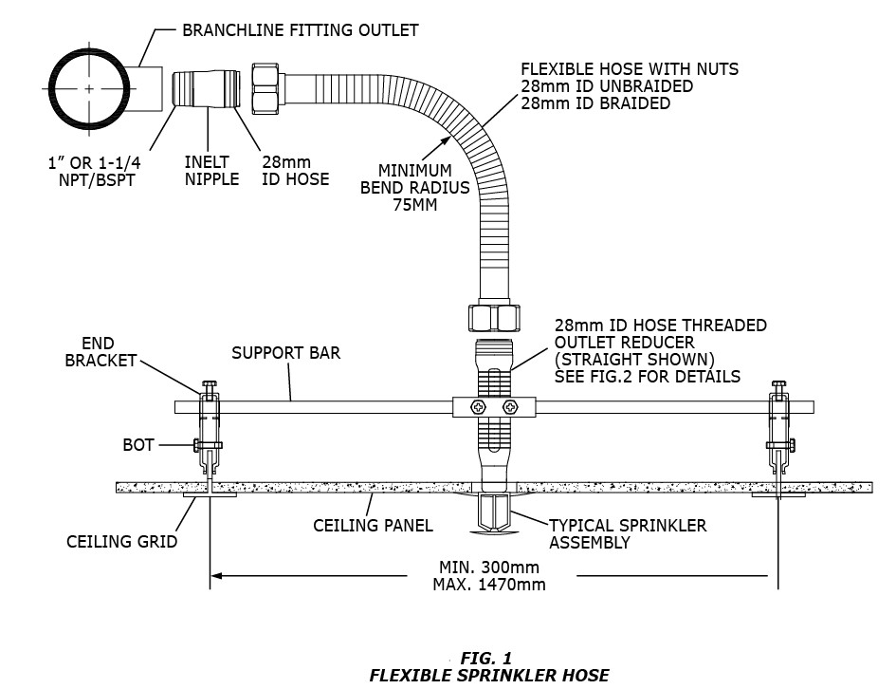

08/11/17

Suggested Methods of Proper Hose Alignment & Examples of Improper Methods

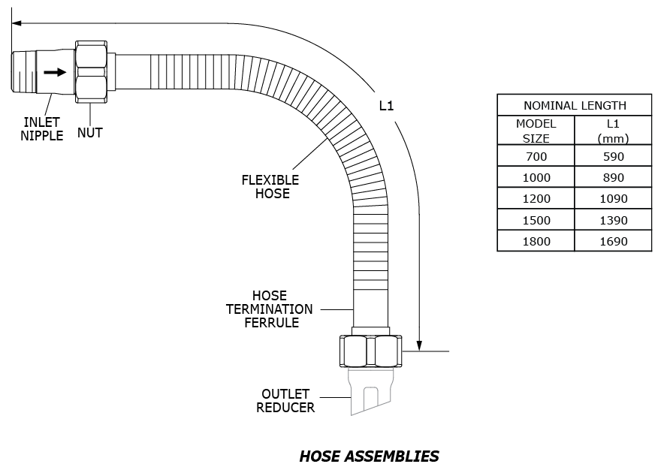

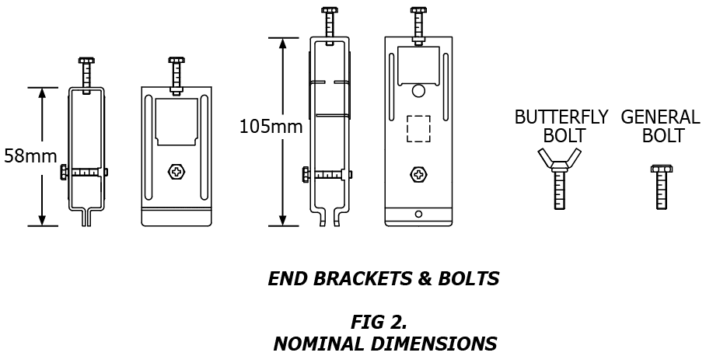

08/11/17

Suggested Methods of Proper Hose Alignment & Examples of Improper Methods

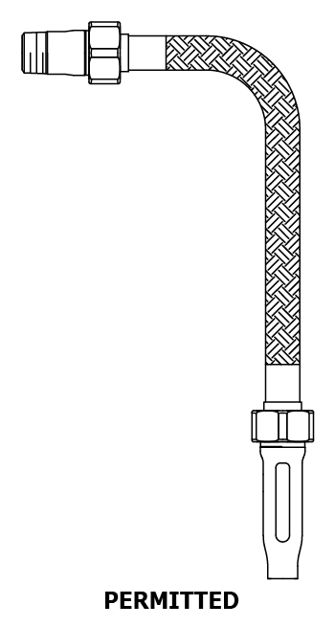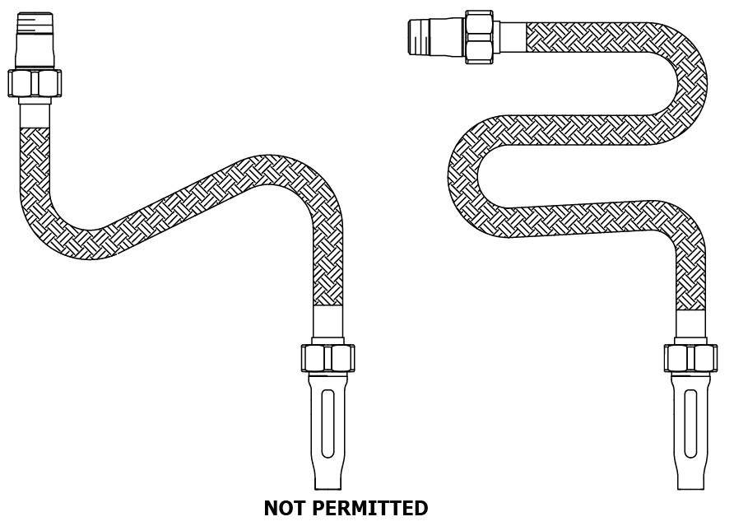

Make sure proper length of flexible hose from the branch line connection to the sprinkler location. Ensure that the maximum numbers of specified bends with the minimum bend radius are adhered to. Use a radius tool to ensure the proper minimum bend radius of Approval Agencies, which is 75 mm, in case of LPCB. In addition, the radius of the flex hose must NOT fall in the non-corrugated ends.
08/11/17

LPCB APPROVED RASCOFLEX SPRINKLER DROPS OFFERED AS STOCK ASSEMBLIES

TABLE A: LPCB APPROVED RASCOFLEX MODELS

Type | Model No. | Length (mm) | Description
Braided | RF070B | 700 | 1/2" or 3/4" (Outlet) x 1” or 1-1/4" (Inlet) Braided Hose
 | RF100B | 1000 | 1/2" or 3/4" (Outlet) x 1” or 1-1/4” (Inlet) Braided Hose
 | RF120B | 1200 | 1/2" or 3/4" (Outlet) x 1” or 1-1/4” (Inlet) Braided Hose
 | RF150B | 1500 | 1/2" or 3/4" (Outlet) x 1” or 1-1/4” (Inlet) Braided Hose
 | RF180B | 1800 | 1/2" or 3/4" (Outlet) x 1” or 1-1/4” (Inlet) Braided Hose
Unbraided | RF070U | 700 | 1/2" or 3/4" (Outlet) x 1” or 1-1/4” (Inlet) Unbraided Hose
 | RF100U | 1000 | 1/2" or 3/4" (Outlet) x 1” or 1-1/4” (Inlet) Unbraided Hose
 | RF120U | 1200 | 1/2" or 3/4" (Outlet) x 1” or 1-1/4” (Inlet) Unbraided Hose
 | RF150U | 1500 | 1/2" or 3/4" (Outlet) x 1” or 1-1/4” (Inlet) Unbraided Hose
 | RF180U | 1800 | 1/2" or 3/4" (Outlet) x 1” or 1-1/4” (Inlet) Unbraided Hose

LPCB DESIGN CRITERIA
- Intended for use in wet or dry systems between the branch line and sprinkler head.
- May be used in applications where little or no differential movement between the two ends is ex- pected after installation (e.g. supply to single sprinklers in suspended ceilings.
- Use only to be directly connected to fire sprinklers.
- Approved as a Type 2 hose of moderate flexibility in accordance with LPS 1261.
- Must be used in accordance with an appropriate sprinkler installation code such as LPS sprinkler rules.
- Maximum working pressure of 14 Bar.
- Maximum ambient temperature of 149° C
- Minimum bend radius of 75 mm (Refer to Fig. 1)
- Approved for the following locations:
08/11/17

RFxxxB Series (Braided Hose)

Assembly Length (mm) | Pre-Calculated |  | Fully Hydraulically Calculated
 | Town Mains | Pumps
700 | Yes | Yes | Yes
1000 | Yes | Yes | Yes
1200 | Yes | Yes | Yes
1500 | Yes | Yes | Yes
1800 | Yes | Yes | Yes

- All pipe work supplying RASCOFLEX flexible sprinkler connection assemblies in pre-calculated systems shall be sized as distribution mains.
- In suspended ceilings RASCOFLEX flexible sprinkler connection must be installed in accordance with this data sheet

- In suspended ceiling, RASCOFLEX flexible sprinkler connection must be connected to the ceiling support system with brackets supplied.
- LPCB Equivalent Length of RASCOFLEX as follows:

RFxxxB Series (Braided Hose)
Assembly Length (mm) | Number of 90° Bends | Equivalent Length of DN25 Sch. 40 Pipe at C=120 in Meters
700 | 1 | 5.0
1000 | 1 | 7.2
1200 | 2 | 7.1
1500 | 2 | 7.6
1800 | 3 | 9.4
08/11/17

RFxxxU Series (Unbraided Hose)
Assembly Length (mm) | Number of 90° Bends | Equivalent Length of DN25 Sch. 40 Pipe at C=120 in Meters
700 | 1 | 4.2
1000 | 1 | 5.9
1200 | 2 | 6.7
1500 | 2 | 11.4
1800 | 3 | 13.0

INSTALLATION
- To ensure that the systems work, it is recommended that they are designed, installed, commissioned and maintained by contractors who are approved by LPCB to LPS 1048 (for commercial systems), particularly TB227, and other installation codes such as NFPA13 , NFPA13D, NFPA13R as well as International Fire Code.
- Failure to do so could cause product failure, resulting in serious personal injury and/or property dam- age.
- The user should contact the manufacturer or distributor to ensure they specify the correct type and usage of RASCOFLEX flexible sprinkler drops.
- The end users should ensure the selection of appropriate product with due regard to the installation codes, product training and related questions, and rules applicable to the territories in which these products are being installed. Upon request, further product training will be available through distribu- tion with installation material such as installation instruction guidebook.
- Please refer to the enclosed installation instruction for further detail.

The intended use of RASCOFLEX flexible sprinkler drop is connection between branch line to sprinkler head. Thus flexible sprinkler drop should NOT be used to pass through fire compartments such as penetration seals, fire stopping cavity barriers, and others indicated by Approval Agency.
08/11/17

CARE AND MAINTENANCE
The users are responsible for the inspection, testing, and maintenance of their fire protection systems and devices in compliance with this document and with the applicable standards of the authorities having jurisdiction. The installing contractor should contact manufacturer or distributor in the region in related to any product questions.

It is recommended that automatic sprinkler systems be inspected, tested and maintained by an approved and qualified inspection service in accordance with local requirements and/or national codes.

The life expectancy of RASCOFLEX flexible sprinkler drop is affected by various factors including working conditions and construction of flexible sprinkler drop such as operating temperature, operating pressure, bend radius and bending stress beyond its limitation, the thickness of the corrugation, the corrugation pitch, depth, shape of the corrugation, static condition such as installation beyond design limitations of flexible drop, and unknown factors of installation performed by contractor. Any change in one of these factors will result in a change in the cycle life of flexible sprinkler drop. For longer cycle life of flexible sprinkler drop, it is strongly recommended to follow the guidelines of this manual, appropriate Agency Standards such as LPCB guidelines, FM and UL as well as local authority’s rules and codes. A manufacturer cannot predict and dictate every variable which might be encountered in every application, installation or any misapplication, mechanical damage, and/or any uncontrollable situation may arise while installation.

In case of malfunctioning of flexible sprinkler drop, it is recommended to contact regional distributors for further information. Distributors and manufacturer will assist end user to investigate the root cause of an issue and prevent further malfunctioning of product. Once the flexible sprinkler drops or any fire protection systems are in place, the end user should maintain the fire systems through qualified fire protection maintenance service provider to maximize system integrity to avoid failure, and ensure fast and effective response in a fire emergency.

When water additives are added, according to NFPA and International Fire Code, depending on several variables, the additives need to be between 30 – 70% of the total volume of water in the wet sprinkler system. However, the user of flexible sprinkler drops must adhere to the industrial installation regulation such as NFPA as well as local authority rules and regulations. Failure to do so may cause serious personal injury and property damage. It is recommended to consult or seek advice the compatibility of water additives with installation regulators and guidelines such as NFPA and International Fire Code.

In addition, depending on the usage and where it is applicable, the user of flexible drop must follow and adhere to the compliance with appropriate local water regulatory requirements, regulations, rules, or appropriate restrictions on use.

08/11/17

After a fire protection system is in place for service, inform the proper authorities and those responsible for monitoring and maintaining proprietary and/or central station alarms. Before closing a fire protection system control valve for inspection or maintenance work on the fire protection system that it controls, permission to shut down the effected fire protection system must first obtain from the proper authorities and all personnel who may be affected by this action must be notified.

It is the responsibility of the system designer to verify suitability of RASCOFLEX stainless steel flexible drop for use with the intended fluid media.
The effect of chemical composition and exposure, pH level, operating temperature, chloride level, oxygen level, UV light and flow rate on stainless steel flexible drop must be evaluated by the material specifier to confirm system life will be acceptable for the intended service and usage. The flexible drop is intended for use indoors.

08/11/17

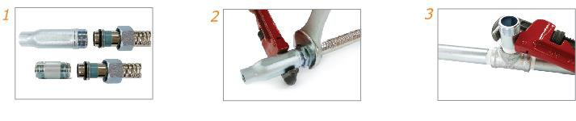
INSTALLATION INSTRUCTIONS i), vi)

- Inspect the flexible drops for any signs of physical damage and check all components are in proper place, particularly sealing gaskets inside of nuts.
- Reconnect the inlet nipple and outlet reducer to the flexible hose by using a wrench with its given torque range.
  - Torque Range of Nut + Inlet Nipple / Outlet reducer: 500kgf/cm² approximately
- Apply pipe joint compound or teflon tape (PTFE) to the branch line inlet nipple in accordance with the pipe joint compound or tape manufacturer’s instructions. Tighten the inlet nipple to the branch line with its given torque range.
  - Torque Range of Inlet Nipple + Branch Pipe: 850~900kgf/cm² approximately
WARNING : DO NOT apply pipe joint compound or teflon tape (PTFE) on the outlet nipple thread connected to the flexible hose.

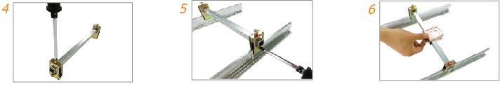

08/11/17

- Position each end bracket to be lined with the ceiling grid and connect the support bar to each end bracket. Once again make sure each end bracket is lined with the ceiling grid and tighten the bolts securely.
- Attach the end brackets to each ceiling grid and tighten the bolt to secure onto the grid, as shown above with its given torque range.
  - Torque Range of End Bracket Bolts to Ceiling Grid: 45kgf/cm² approximately
- Place center bracket at the desired location.

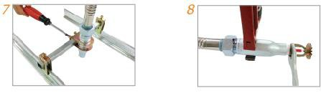
- Insert the outlet reducer that connected to the flexible hose into the center bracket and tighten two bolts of the center bracket with its given torque range.
  - Torque Range of Center Bracket Bolts: 65kgf/cm² approximately
- Apply pipe joint compound or teflon tape (PTFE) to the sprinkler head in accordance with the NFPA guidelines and sprinkler head manufacturer’s installation instructions.

